课 题 | Unit 4 where is my car?
教学目标 | 1.认读新词：cap ball car boat map通过听听做做的活动，让学生练习并运用所学的词汇。  2、了解一些简单的指示语，要求学生能听懂并按照指令做出相应的动作。
教学重点 | 词汇的学习。
教学难点 | 本课词汇的认读
一、【三会词汇】根据所给英语写出相应的汉语意思。
1．peach________ 2.pear________ 3．orange________
4.watermelon________ 5．apple________ 6.banana________
7．strawberry________ 8．grape________ 9.like________
10．some________ 11.thanks________
二、【二会词汇】根据所给英语写出相应的汉语意思。
1．hungry________ 2.yes________ 3．please________
4.them________ 5．very much________ 6．taste________
7.queen________ 8．fruit________ 9.certainly________
10．do not________ 11.quiet________www.bcjy1三、【二会词汇】给英文单词选出正确的汉语意思。
( )1.more ( )2.rainbow ( )3.rain
( )4.snake ( )5.tiger ( )6.taxi
A．彩虹 B．更多的 C．蛇 D．出租车 E．雨；下雨 F．老虎
四、为下面的句子选择正确的汉语翻译。
( )1.I like them very much.
( )2.Let's have some peaches and pears.
( )3.Have some fruits.

( )4.Do you like bananas?
( )5.Sorry，I don't like bananas.
( )6.What about pears?
A．你喜欢吃香蕉吗？
B．梨怎么样？
C．我非常喜欢它们。
D．吃一些水果吧。
E．抱歉，我不喜欢吃香蕉。
F．让我们吃一些桃子和梨吧。
综合全练全测
听力部分
一、听录音，选一选。
( )1.A.P p B．Q q C．D d
( )2.A.Q o B．P o C．Q p
( )3.A.pear B．bear C．peach
( )4.A.Q B．queen C．new
( )5.A.water B．apple C．watermelon
二、根据录音选出相应的图片。
( )1.A. INCLUDEPICTURE "香蕉5.TIF" \* MERGEFORMAT INCLUDEPICTURE "香蕉5.TIF" \* MERGEFORMAT INCLUDEPICTURE "香蕉5.TIF" \* MERGEFORMAT INCLUDEPICTURE "香蕉5.TIF" \* MERGEFORMAT  B. INCLUDEPICTURE "葡萄4.TIF" \* MERGEFORMAT INCLUDEPICTURE "葡萄4.TIF" \* MERGEFORMAT INCLUDEPICTURE "葡萄4.TIF" \* MERGEFORMAT INCLUDEPICTURE "葡萄4.TIF" \* MERGEFORMAT 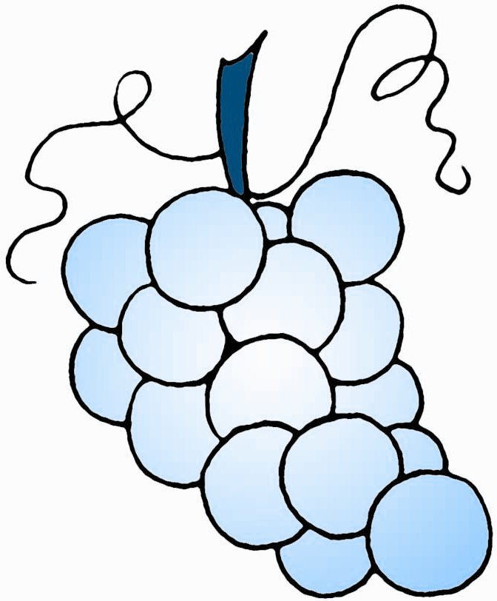
( )2.A. INCLUDEPICTURE "梨2.TIF" \* MERGEFORMAT INCLUDEPICTURE "梨2.TIF" \* MERGEFORMAT INCLUDEPICTURE "梨2.TIF" \* MERGEFORMAT INCLUDEPICTURE "梨2.TIF" \* MERGEFORMAT 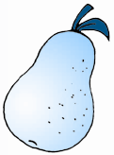 B. INCLUDEPICTURE "桃2.TIF" \* MERGEFORMAT INCLUDEPICTURE "桃2.TIF" \* MERGEFORMAT INCLUDEPICTURE "桃2.TIF" \* MERGEFORMAT INCLUDEPICTURE "桃2.TIF" \* MERGEFORMAT 
( )3.A. INCLUDEPICTURE "兔14.TIF" \* MERGEFORMAT INCLUDEPICTURE "兔14.TIF" \* MERGEFORMAT INCLUDEPICTURE "兔14.TIF" \* MERGEFORMAT INCLUDEPICTURE "兔14.TIF" \* MERGEFORMAT 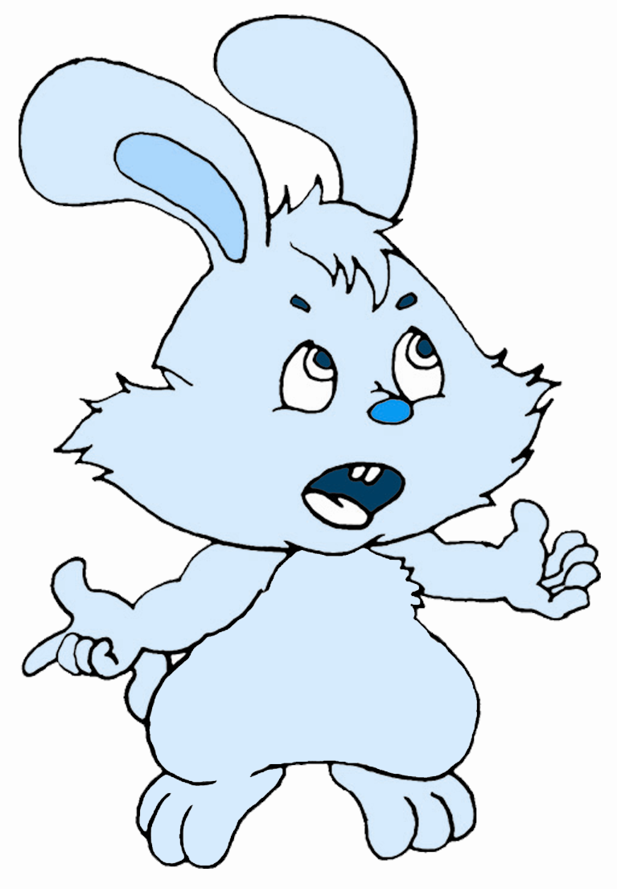 B. INCLUDEPICTURE "猫15.TIF" \* MERGEFORMAT INCLUDEPICTURE "猫15.TIF" \* MERGEFORMAT INCLUDEPICTURE "猫15.TIF" \* MERGEFORMAT INCLUDEPICTURE "猫15.TIF" \* MERGEFORMAT 
( )4.A. INCLUDEPICTURE "橘子2.TIF" \* MERGEFORMAT INCLUDEPICTURE "橘子2.TIF" \* MERGEFORMAT INCLUDEPICTURE "橘子2.TIF" \* MERGEFORMAT INCLUDEPICTURE "橘子2.TIF" \* MERGEFORMAT 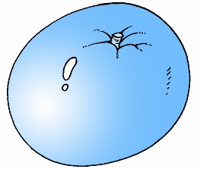 B. INCLUDEPICTURE "苹果2.TIF" \* MERGEFORMAT INCLUDEPICTURE "苹果2.TIF" \* MERGEFORMAT INCLUDEPICTURE "苹果2.TIF" \* MERGEFORMAT INCLUDEPICTURE "苹果2.TIF" \* MERGEFORMAT 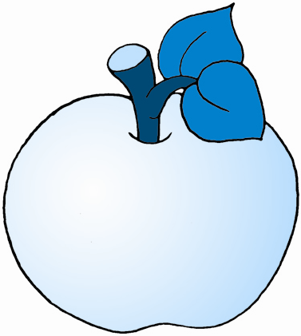
三、选出你所听到的句子。
( )1.A.I like apples. B．I like watermelons.
( )2.A.Do you like pears? B．Do you like grapes?
( )3.A.What about pears? B．What about peaches?
( )4.A.Here you are. B．I have an apple.
( )5.A.I'm hungry. B．No，thank you.
四、听音，给下列句子按(A～F)的顺序排序。
( )1.What about pears?
( )2.Do you like bananas?
( )3.Oh，I like them very much.
( )4.Sorry，I don't like bananas.
( )5.Let's have some pears.
( )6.OK!
笔试部分
五、连一连，为大写字母找到相应的小写字母。
R h
Q q
T b
M m
B r
H t
A i
C l
E a
G c
I e
L g
六、将下列单词和对应的图片连线。
1．pear a. INCLUDEPICTURE "苹果2.TIF" \* MERGEFORMAT INCLUDEPICTURE "苹果2.TIF" \* MERGEFORMAT INCLUDEPICTURE "苹果2.TIF" \* MERGEFORMAT INCLUDEPICTURE "苹果2.TIF" \* MERGEFORMAT
2．orange b. INCLUDEPICTURE "桃2.TIF" \* MERGEFORMAT INCLUDEPICTURE "桃2.TIF" \* MERGEFORMAT INCLUDEPICTURE "桃2.TIF" \* MERGEFORMAT INCLUDEPICTURE "桃2.TIF" \* MERGEFORMAT
3．apple c. INCLUDEPICTURE "草莓5A.TIF" \* MERGEFORMAT INCLUDEPICTURE "草莓5A.TIF" \* MERGEFORMAT INCLUDEPICTURE "草莓5A.TIF" \* MERGEFORMAT INCLUDEPICTURE "草莓5A.TIF" \* MERGEFORMAT 
4．grapes d. INCLUDEPICTURE "橘子2.TIF" \* MERGEFORMAT INCLUDEPICTURE "橘子2.TIF" \* MERGEFORMAT INCLUDEPICTURE "橘子2.TIF" \* MERGEFORMAT INCLUDEPICTURE "橘子2.TIF" \* MERGEFORMAT
5．strawberry e. INCLUDEPICTURE "葡萄4.TIF" \* MERGEFORMAT INCLUDEPICTURE "葡萄4.TIF" \* MERGEFORMAT INCLUDEPICTURE "葡萄4.TIF" \* MERGEFORMAT INCLUDEPICTURE "葡萄4.TIF" \* MERGEFORMAT
6．peach f. INCLUDEPICTURE "梨2.TIF" \* MERGEFORMAT INCLUDEPICTURE "梨2.TIF" \* MERGEFORMAT INCLUDEPICTURE "梨2.TIF" \* MERGEFORMAT INCLUDEPICTURE "梨2.TIF" \* MERGEFORMAT
七、选择填空。
( )1.Sarah______bananas.
A．like B．likes
( )2.Look______the elephant.
A．at B．in
( )3.______you like oranges?
A．Do B．Have
( )4.—Let's go to school.
—______！
A．Hi B．OK
( )5.This is______you.
A．in B．for
( )6.—______are you?
—I'm fine.
A．How old B．How
八、连词成句，把序号写在横线上。
1. apples, have, Let's, some
A B C D
________________________________________________________________.
2．，，，
________________________________________________________________?
3．，，，
________________________________________________________________.
4．，，，
________________________________________________________________.
九、给下列句子找答句。
( )1.May I have a look?
( )2.Here you are.
( )3.Do you like peaches?
( )4.Where are you from?
( )5.Who's that man?

( )6.Good morning!
A．Yes，I do. B．Thank you. C．Sure.
D．He's my father. E．Good morning! F．I'm from China.
听力原文
一、1.D d 2.Q p 3.pear 4.new 5.apple
二、1.—Do you like grapes？
—Yes，I do.
2. —Can I have some pears？
—Certainly!
3．—Do you like rabbits？
—Yes，I do.
4．—Have some apples，please.
—Thank you.
三、1.I like watermelons.
2．Do you like pears?
3．What about peaches?
4．I have an apple.
5．I'm hungry.
四、A. Do you like bananas?
B．Sorry，I don't like bananas.
C．What about pears?
D．Oh，I like them very much.
E．Let's have some pears.
F．OK!

答案
基础全练全测
一、1.桃 2.梨 3.橙子 4.西瓜 5.苹果 6.香蕉 7.草莓 8.葡萄 9.喜欢
10.一些；某些 11.多谢
二、1.饥饿的 2.是；是的 3.请 4.它(她；他)们 5.非常；很多的 6.品尝
7.女王；王后 8.水果 9.当然；可以 10.不是；不要 11.安静的
三、1.B 2.A 3.E 4.C 5.F 6.D
四、1.C 2.F 3.D 4.A 5.E 6.B
综合全练全测
一、1.C 2.C 3.A 4.C 5.B
二、1.B 2.A 3.A 4.B
三、1.B 2.A 3.B 4.B 5.A
四、1.C 2.A 3.D 4.B 5.E 6.F
五、略
六、1—f 2—d 3—a 4—e 5—c 6—b
七、1.B 2.A 3.A 4.B 5.B 6.B
八、 1.CBDA 2.BADC 3.CDAB 4.BDAC
九、1.C 2.B 3.A 4.F 5.D 6.E

